Admin pre-checks
Results:
1. User details
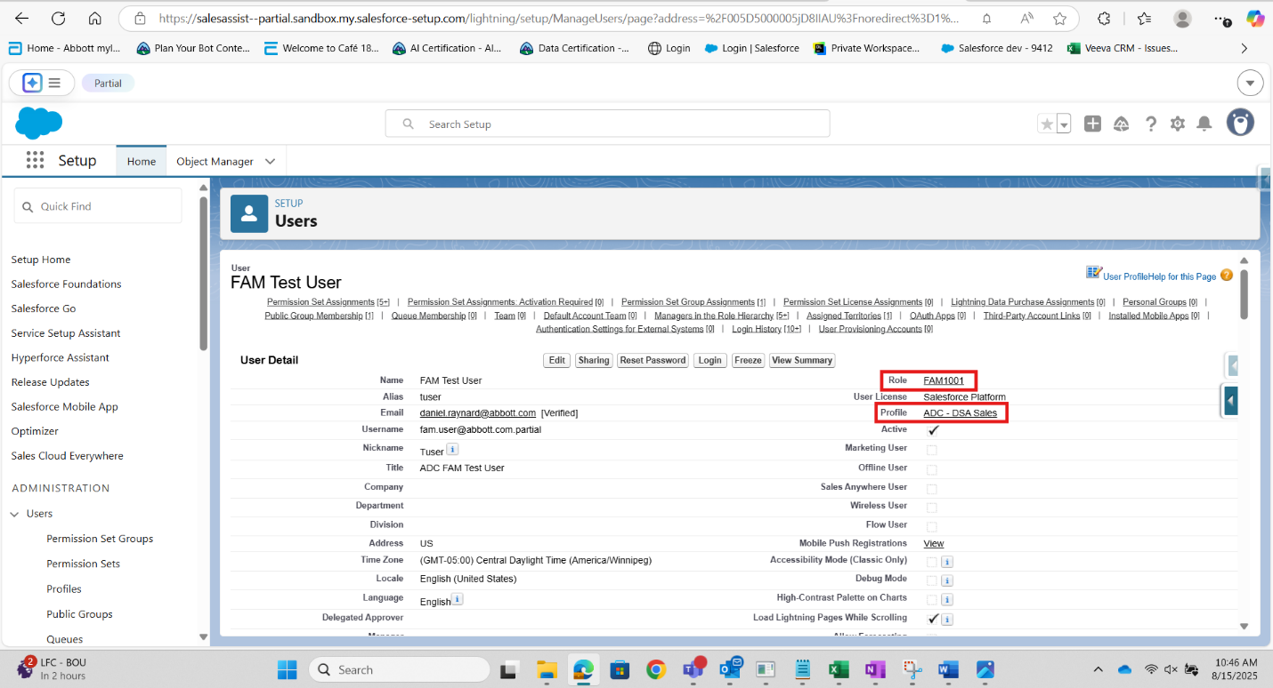
- Permission Set Assignments:
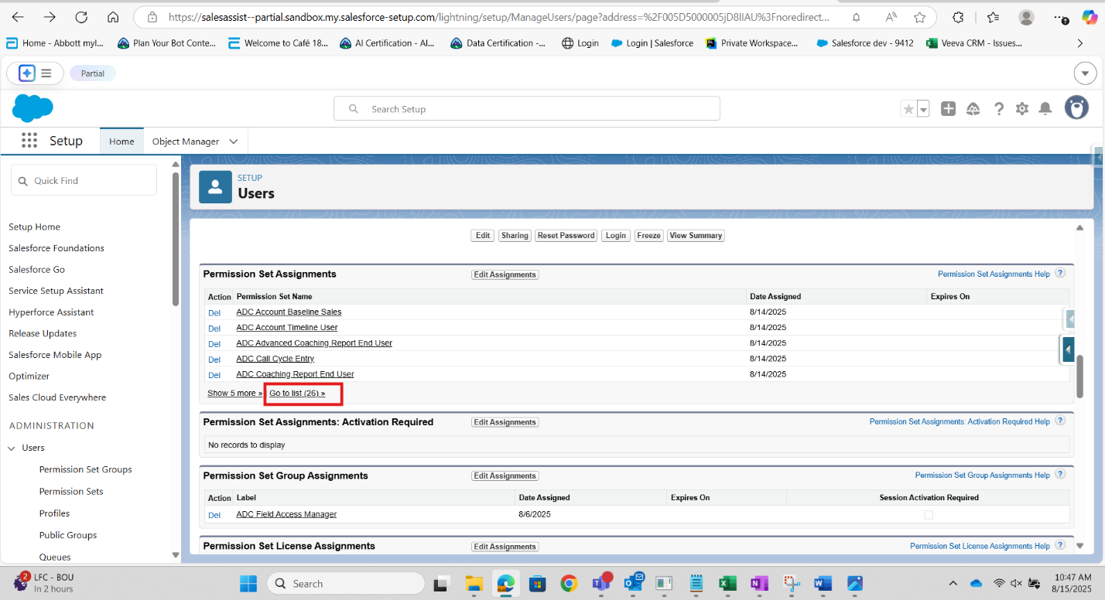
- Permission Set Group: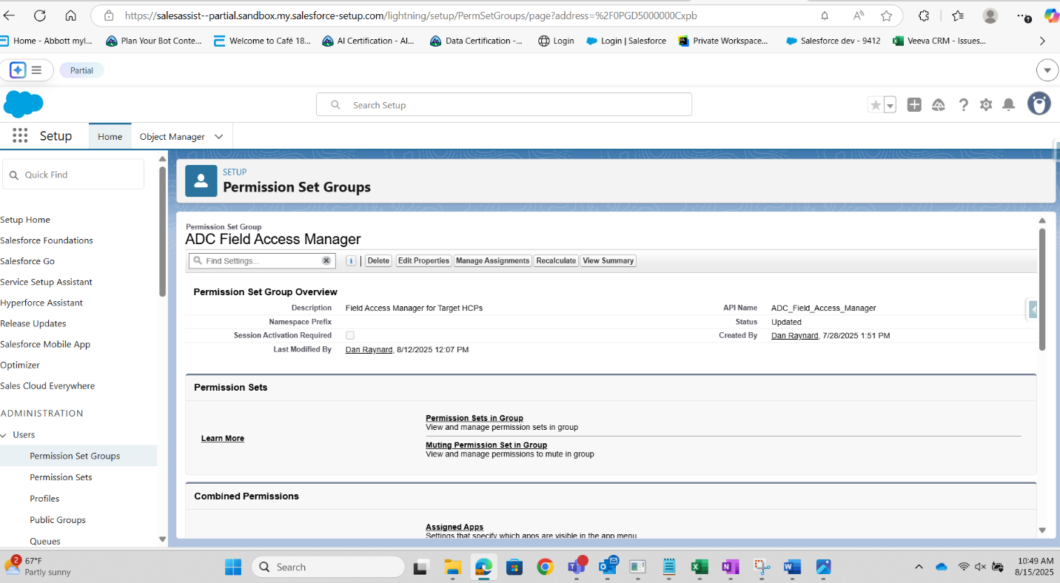

- Territory
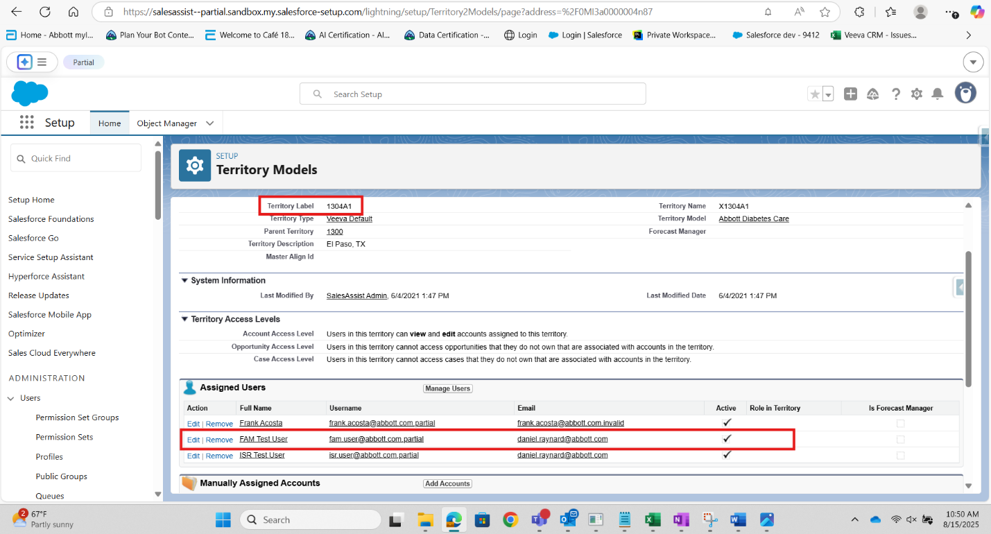
Profile/tab expectations
Reports = Tab Hidden

UI checks:
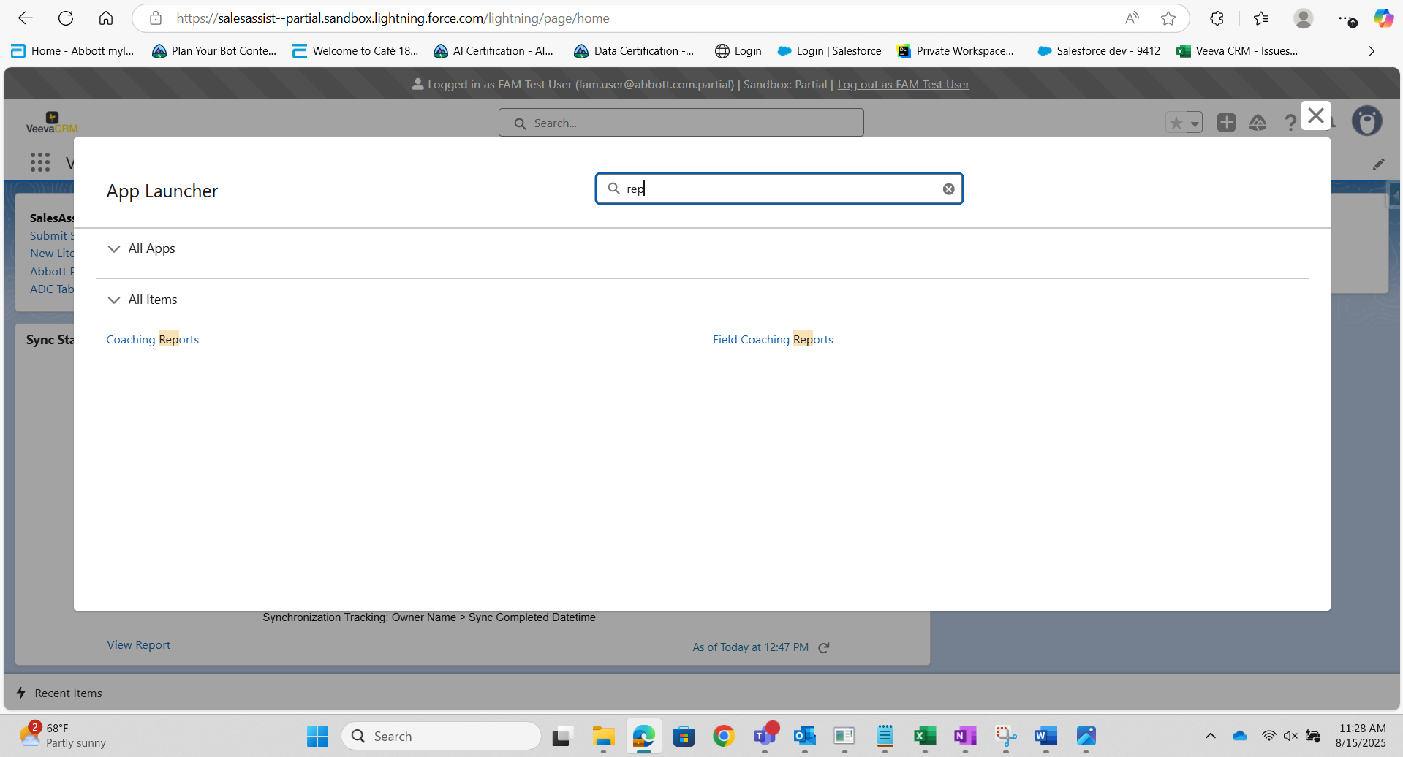
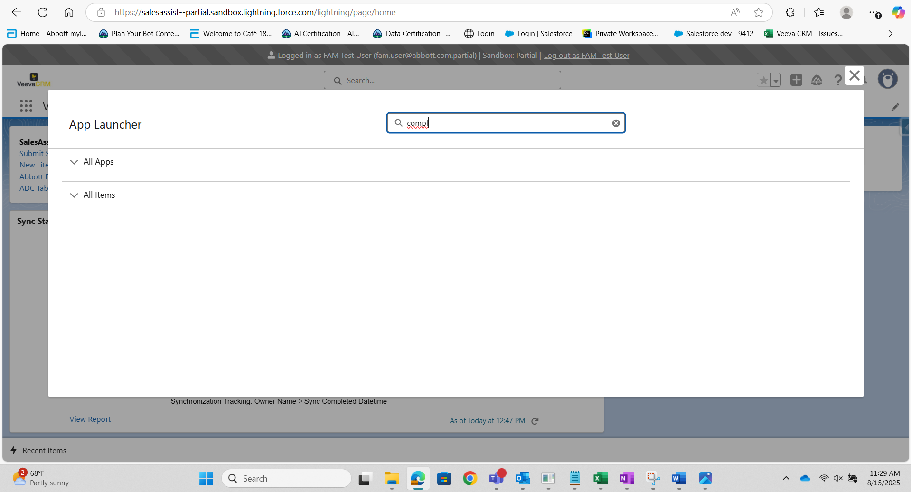
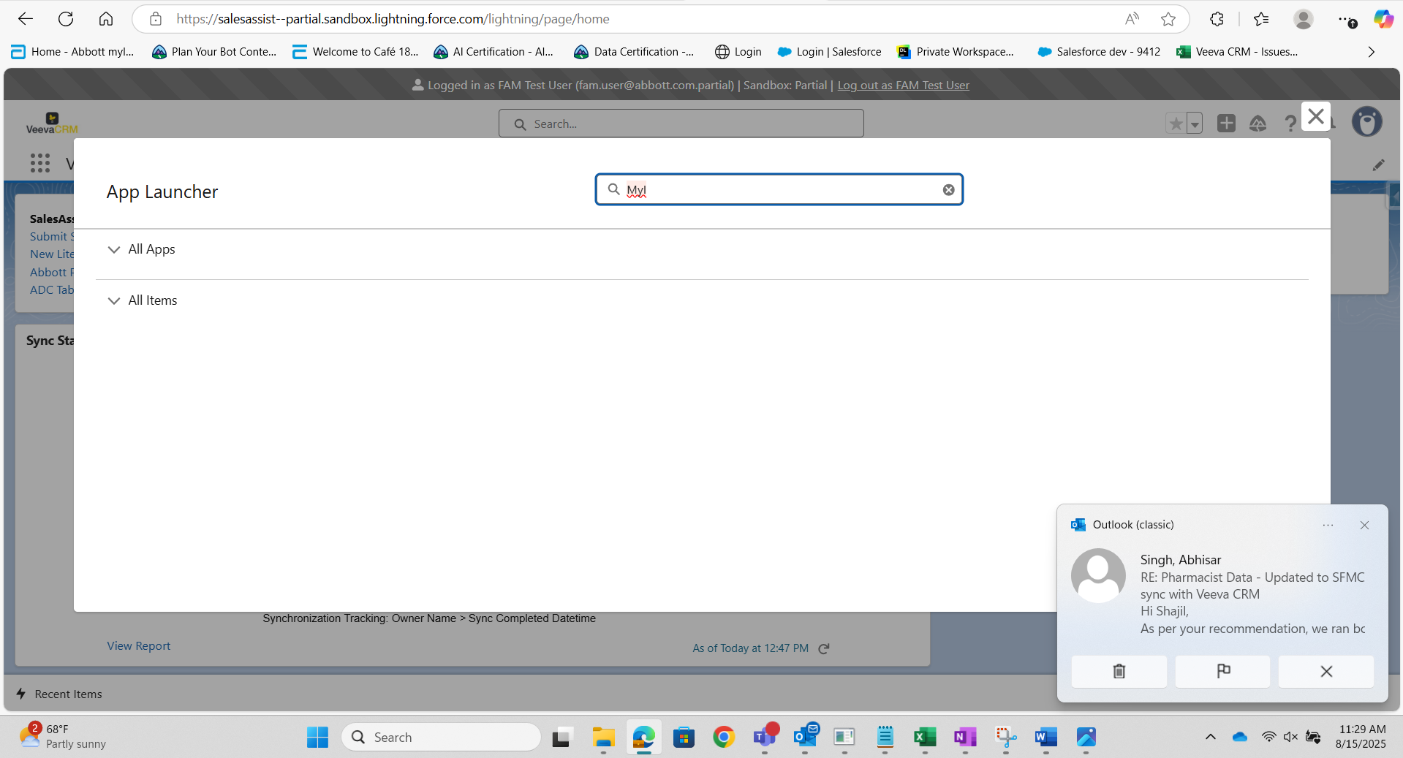
SOQL queries:
Query 1:
-- User / Role / Profile
SELECT Id, Name, Username, Profile.Name, UserRole.Name, IsActive
FROM User
WHERE Username = 'fam.user@abbott.com.partial'

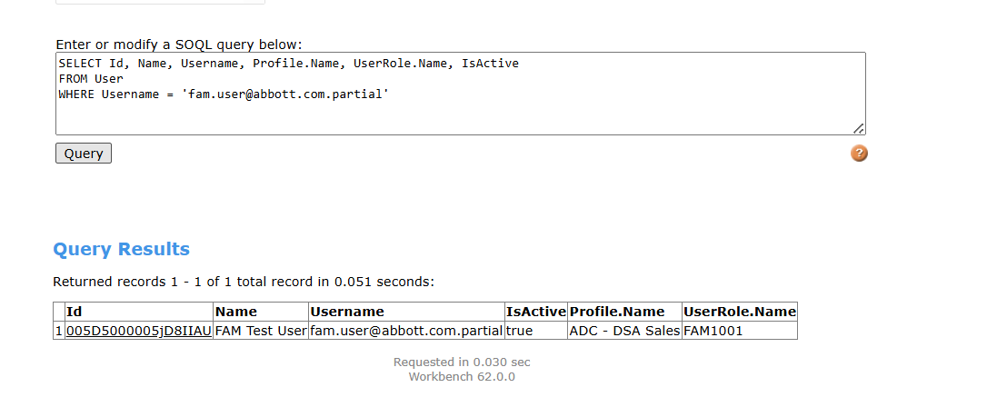
Query 2:
-- Permission sets on the user (prove ADC FAM Permissions is assigned)
SELECT PermissionSet.Name
FROM PermissionSetAssignment
WHERE Assignee.Username = 'fam.user@abbott.com.partial'
ORDER BY PermissionSet.Name

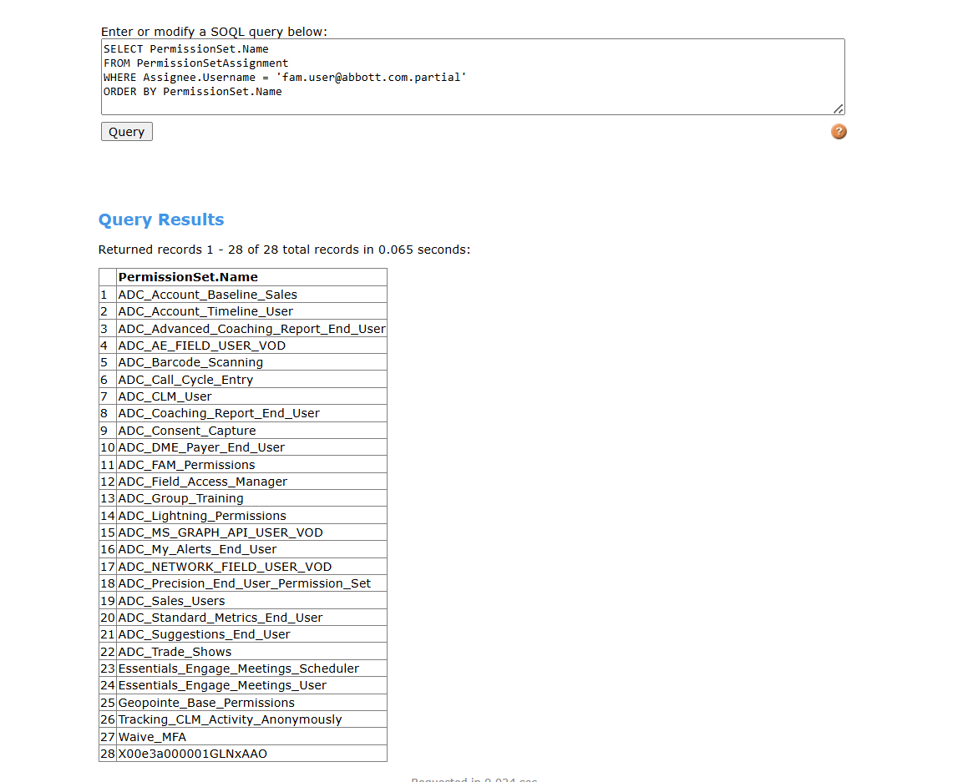
Query 3:
-- Territory assignments (prove FAM territory)
SELECT Territory2.Name, Territory2.DeveloperName, IsActive
FROM UserTerritory2Association
WHERE User.Username = 'fam.user@abbott.com.partial' AND IsActive = true
ORDER BY Territory2.Name

Query 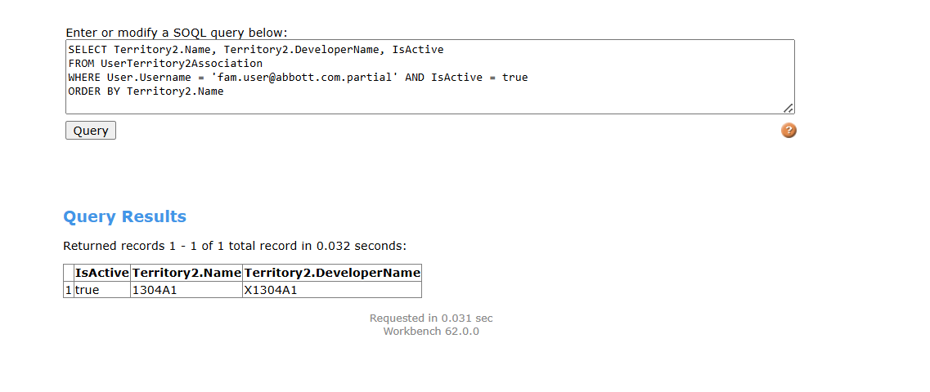
Query 4:
--Object access to prove Remote Sampling/MyInsights are blocked
SELECT ParentId, SobjectType, PermissionsRead, PermissionsCreate, PermissionsEdit, PermissionsDelete
FROM ObjectPermissions
WHERE ParentId IN (
SELECT PermissionSetId FROM PermissionSetAssignment
WHERE Assignee.Username = 'fam.user@abbott.com.partial'
)
AND SobjectType IN ('vod__Sample_Order_vod__c','vod__MyInsights_Data_vod__c')
ORDER BY SobjectType
